CYC Open T shirt Order Info

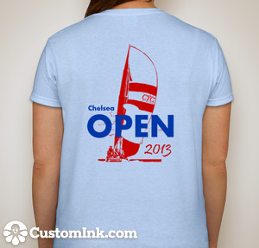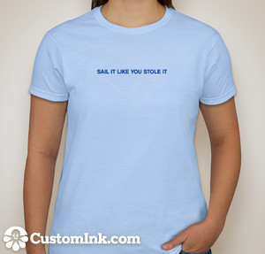
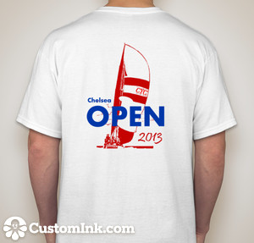

Order by email to michaelaiellosr@aol.com NOT LATER THAN MAY 15
Be sure to include the following:

Mens/Ladies : Lady’s T is a women’s cut
Color: Men white only, Ladies white or pink (not blue as shown)
Size: XS, S, M, L, XL-3XL
How Many?
Your telephone number:
Your Name:

LIMITED INVENTORY AVAILABLE ON RACE DATE, DON’T DEPEND ON PURCHASING THEN

